### 

**1 Launching the Application** **3**

1.1 Splash Screen 3

1.2 Login Screen 4

**2.0 Directie Account Registration** **5**

2.1 Account Registration Screen 5

**3.0 How to login** **7**

3.1 Through Directie Account 7

3.2 Through Facebook Account 8

3.3 Through Google Account 9

**4.0 Homepage** **10**

4.1 How to start a journey 11

4.1.1 “Rules” during a journey 12

4.2 More Details 13

**5.0 Side Menu** **14**

5.1 Edit Profile 15

5.1.1 Editing your name 16

5.1.2 Editing your date of birth 16

5.1.3 Editing your gender 16

5.1.4 Editing your profile picture 17

5.2 Logout 18

### 

### **1 Launching the Application**

#### **1.1 Splash Screen**



*Figure 1.0 Splash Screen*

When the user launches the application, he/she would have to wait for the application to be completely loaded. What they would see will be the splash screen as seen above in Figure 1.0

#### **1.2 Login Screen**

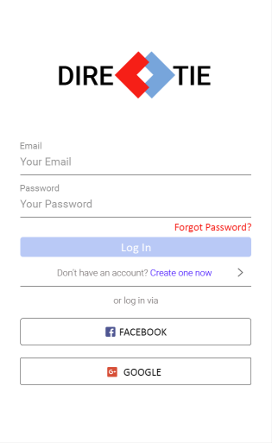

*Figure 2.0 Login Screen*

After the application is fully loaded, the user will be brought to the login screen as shown above in Figure 2.0 as he/she has not logged in to the application before.

* *Note: If the user has logged in to the application before and not logged out, he/she will be brought to the homepage instead of the login page.*

#### 

### **2.0 Directie Account Registration**

#### **2.1 Account Registration Screen**

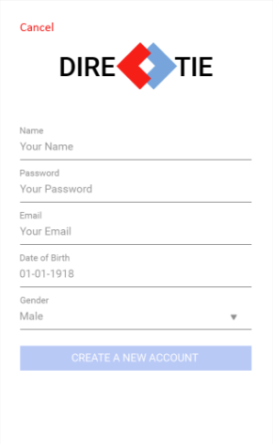

*Figure 3.0 Account Registration Screen*

To be able to login, you’ll need either a Directie, Facebook or Google account. In this part of the guide, you will be shown how to create a ‘Directie’ account.

**Step 1:**

Tap on “Create one now” below the login button on the login page as seen in Figure 2.0 previously.

**Step 2:**

Enter all the necessary fields:

* Name
* Password
* Email
* Gender
* Date of Birth

**Step 3:**

Proceed to tap on “Create a new account” at the bottom of the screen and if everything is filled up properly, your Directie account will be created successfully.

### **3.0 How to login**

#### **3.1 Through Directie Account**



*Figure 4.0 Directie Login Screen*

**Step 1:**

Enter your Directie account credentials (Email & Password) into the the fields accordingly

**Step 2:**

Tap on “Log In” and if the credentials you have entered are correct, you will be authenticated and be brought to the homepage of the application.

#### **3.2 Through Facebook Account**

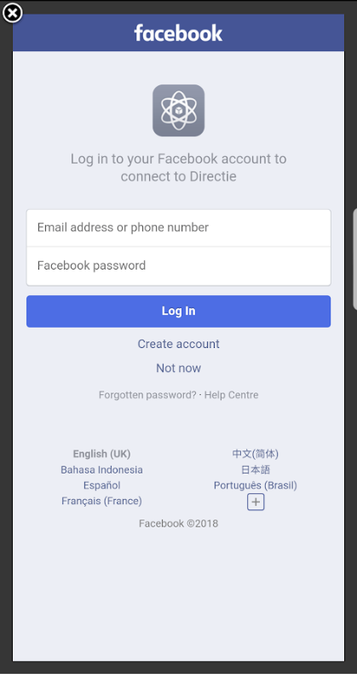

*Figure 5.0 Facebook Login Screen*

**Step 1:**

Tap on the “Facebook” button at the bottom part of the application’s login screen to be brought to Facebook’s login page as seen in Figure 5.0 above.

**Step 2:**

Enter your credentials for your Facebook account.

**Step 3:**

Tap on “login” and you will be authenticated through your Facebook account and be brought to the homepage of the application.

#### **3.3 Through Google Account**

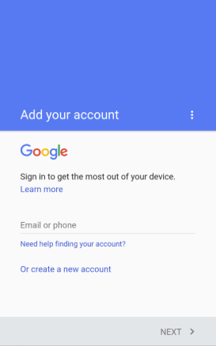

*Figure 6.0 Google Login Screen*

**Step 1:**

Tap on the “Google” button at the bottom part of the application’s login screen to be brought to Google’s login page as seen in Figure 6.0 above.

* *Note: You will be able to use currently saved Google accounts on your phone.*

**Step 2:**

Enter your email for your Google account and tap on “next” at the bottom right.

**Step 3:**

Enter your password for your Google account and tap on “next” at the bottom right.

You will then be authenticated through your Google account and be brought to the homepage of the application.

### **4.0 Homepage**

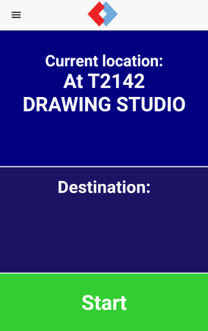

*Figure 7.0 Home Screen*

This is the page which logged in users will see. As seen in Figure 7.0 above, the current location of the user will be shown and a voice message will also inform the user of his/her current location.

On this page, a voice message will prompt the user for a destination that he/she wants to navigate to.

The side menu can be accessed by tapping on the hamburger button on the top left of the screen or by swiping right on the screen.

#### **4.1 How to start a journey**

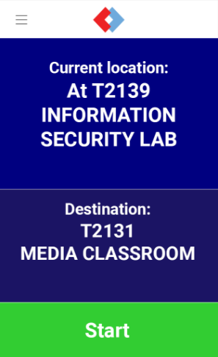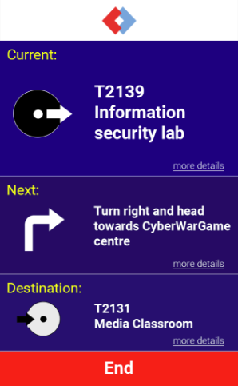

*Figure 8.0 Before tapping “Start” Figure 9.0 After tapping “Start”*

**Step 1:**

Say out the destination that you want to go to after the voice message prompts you for it or after ‘waking’ it up by double tapping the screen. For the non-VI, you can type in the destination after tapping the the area under “Destination”.

**Step 2:**

Proceed to tap on the “Start” button at the bottom of the screen and you will be brought to another page as shown in Figure 9.0 whereby directions to the destination will be shown and read out to the user.

* *Note: To repeat the directions/information read out, you can tap on the respective boxes. For example, if the you want to repeat the direction to the next beacon, you can tap on the box containing the direction and it will be read out again.*

**Step 3:**

Once you have reached your destination, the application will inform you that you have reached your destination and it will end the journey automatically. You will be able to start another journey as the application will move you back to the homepage as well.

* Note: To end the journey before reaching the destination, tap on the “End” button at the bottom of the screen as shown in Figure 9.0 above.

##### **4.1.1 “Rules” during a journey**

* When an instruction is being read out, the user should stop and listen to it till the end before moving again.
* User should stop and wait for instruction upon arrival of each beacon.
* If the user has reached a point where there is a wall in front, stop and listen to the application to guide him/her back to the correct facing direction.
* Hold the phone with the back of the phone facing the ground.

#### 

#### **4.2 More Details**



*Figure 10.0 Screenshot of More Details*

This page can be accessed by tapping on “more details” previously seen in Figure 9.0.

It shows additional information like the description and pictures related to the location where the user is at and going to.

By tapping the arrow on the top left, you will be brought back to the previous screen.

### 

### **5.0 Side Menu**

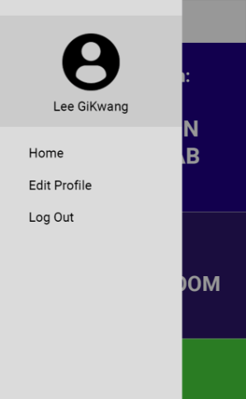

*Figure 11.0 Screenshot of Side Menu*

The side menu will allow the user to access their profile, go back to the homepage, edit profile as well as logging out of their account.

By tapping on “Home” user will be brought to the home page.

#### **5.1 Edit Profile**

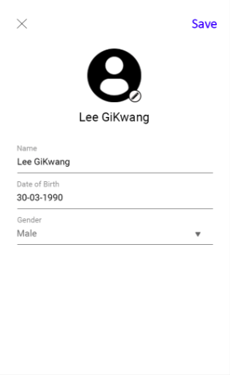

*Figure 12.0 Screenshot of Edit Profile Screen*

The page to edit your profile information can be seen in Figure 12.0 above.

To reach this page, tap on “Edit Profile” in the side menu.

##### **5.1.1 Editing your name**

**Step 1:**

To edit your name used on your profile, tap on the “Name” textfield and a keyboard will appear, allowing you to type your desired name.

**Step 2:**

Tap on “Save” on the top right of the screen to save the name you have just entered as your new profile name.

##### **5.1.2 Editing your date of birth**

**Step 1:**

To edit your date of birth, tap on the “Date-of-Birth” field and a date picker will appear, allowing you to choose your desired date of birth.

**Step 2:**

Tap on “Done” on the top right of the date picker.

**Step 3:**

Tap on “Save” on the top right of the screen to save the date of birth you have just entered.

##### **5.1.3 Editing your gender**

**Step 1:**

To edit your gender used on your profile, tap on the “Gender” field and a dialogue box will appear, allowing you choose your gender.

**Step 2:**

Tap on “Ok” on the bottom right of the dialogue box.

**Step 3:**

Tap on “Save” on the top right of the screen to save the gender you have just chose.

##### 

##### **5.1.4 Editing your profile picture**

**Step 1:**

To edit your profile picture, tap on the edit icon beside the profile picture and you will be able to choose an image from your phone’s gallery as your profile picture.

**Step 2:**

Tap on “Save” on the top right of the screen to save the image you have just chose as your new profile picture.

#### **5.2 Logout**

To logout of your account, tap on logout located in the side menu. This will log you out of your account and you will be brought to the login screen.